**Report 1: Image Feature Detection and Analysis**

**M5281054 WANG Binghao**

**1. Objective**

To evaluate and compare different image feature detection methods, analyzing their effectiveness and limitations across various scenarios.

**2. Development Environment**

1. Python Installation
   * Recommended version: Python 3.8.6
2. Required Packages
   * OpenCV-Python: pip install opencv-python
   * OpenCV-Contrib-Python: pip install opencv-contrib-python
   * Additional dependencies as needed

**3. Experiments**

Construct some codes to extract image

Harris Corner Detection

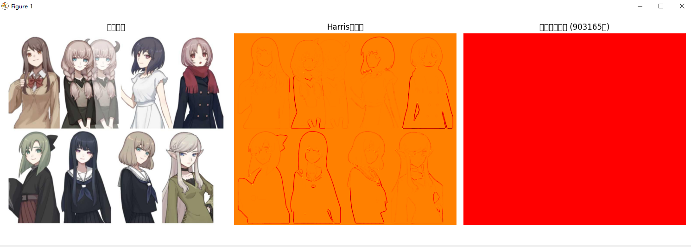

SURF (Speeded-Up Robust Features)

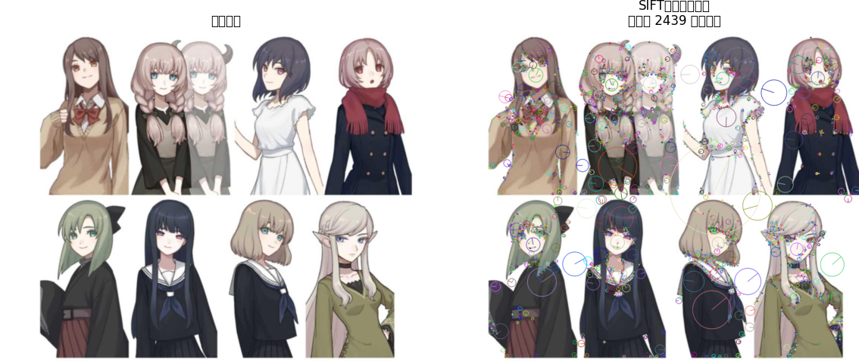

ORB (Oriented FAST and Rotated BRIEF)

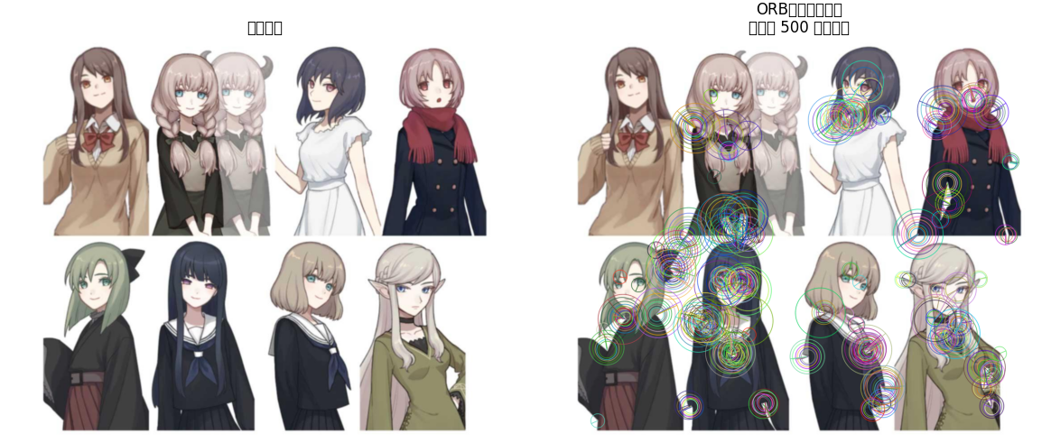

MSER (Maximally Stable Extremal Regions)

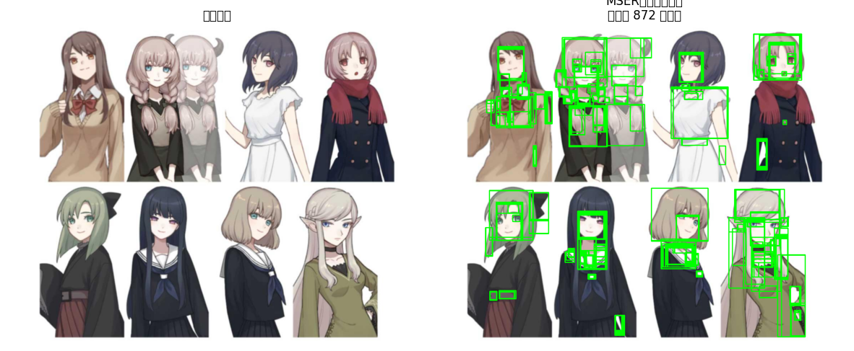

KAZE/AKAZE

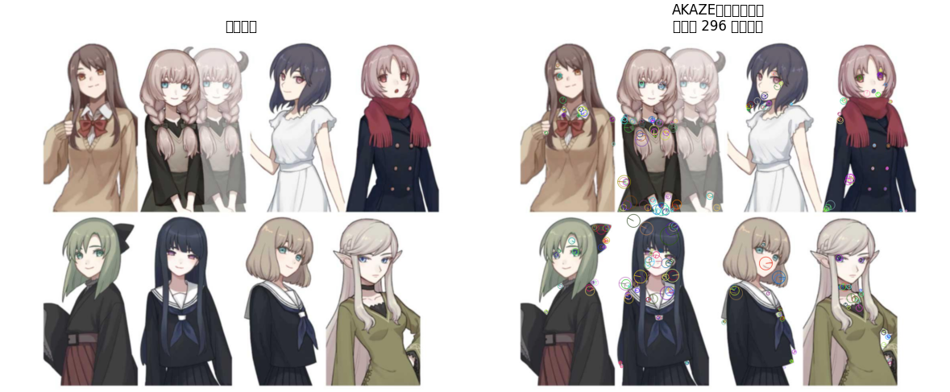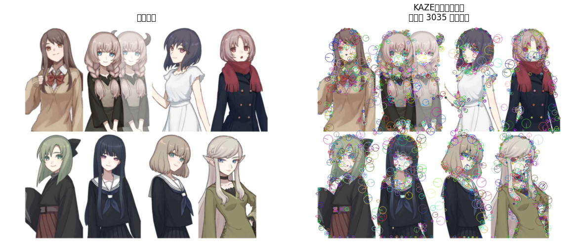

Test Images

Evaluate each method on the following image types:

1. Indoor Scenes

Empty office

Harris detector: 1038 features detected

ORB detector: 1000 features detected

MSER detector: 479821 features detected

KAZE detector: 667 features detected

AKAZE detector: 536 features detected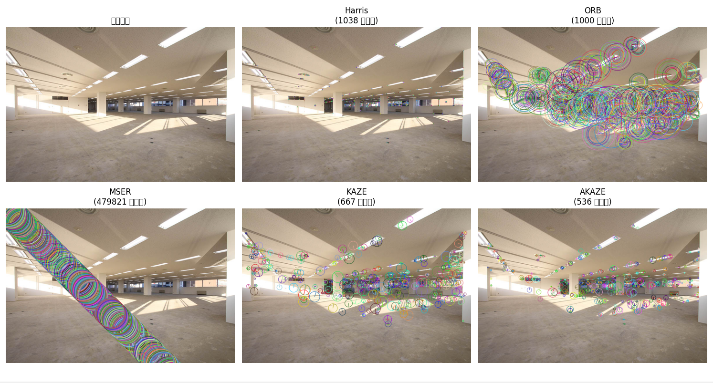

U-Aizu lecture room

Harris detector: 3961 features detected

ORB detector: 1000 features detected

MSER detector: 1106592 features detected

KAZE detector: 1686 features detected

AKAZE detector: 1288 features detected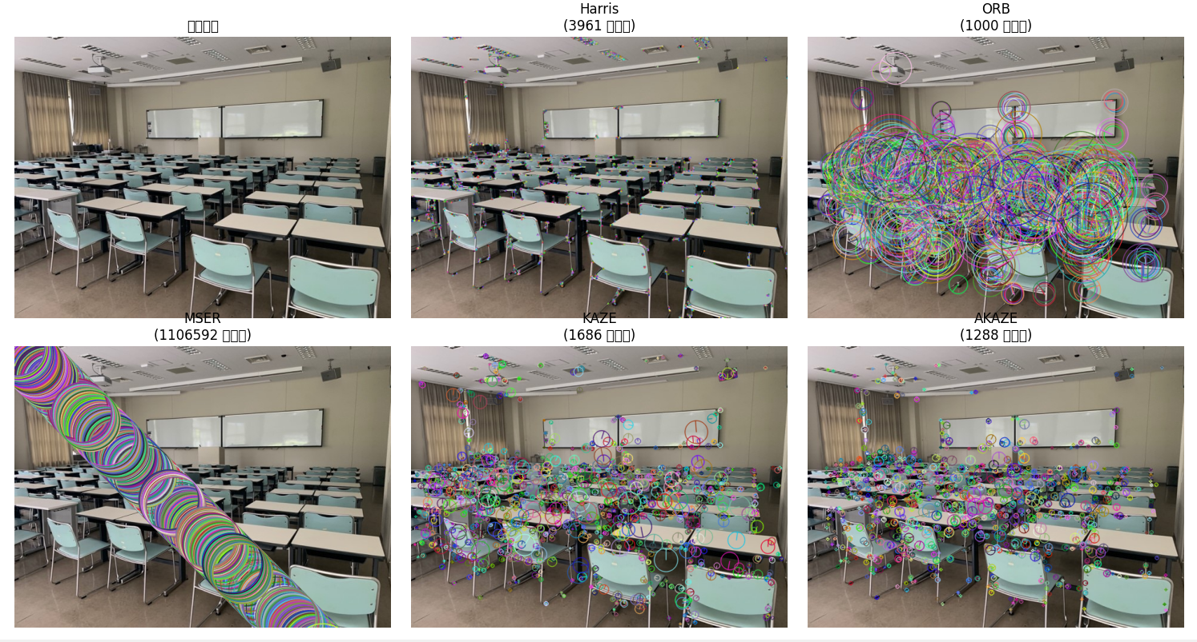

U-Aizu building

Harris detector: 9781 features detected

ORB detector: 1000 features detected

MSER detector: 6190223 features detected

KAZE detector: 28623 features detected

AKAZE detector: 28478 features detected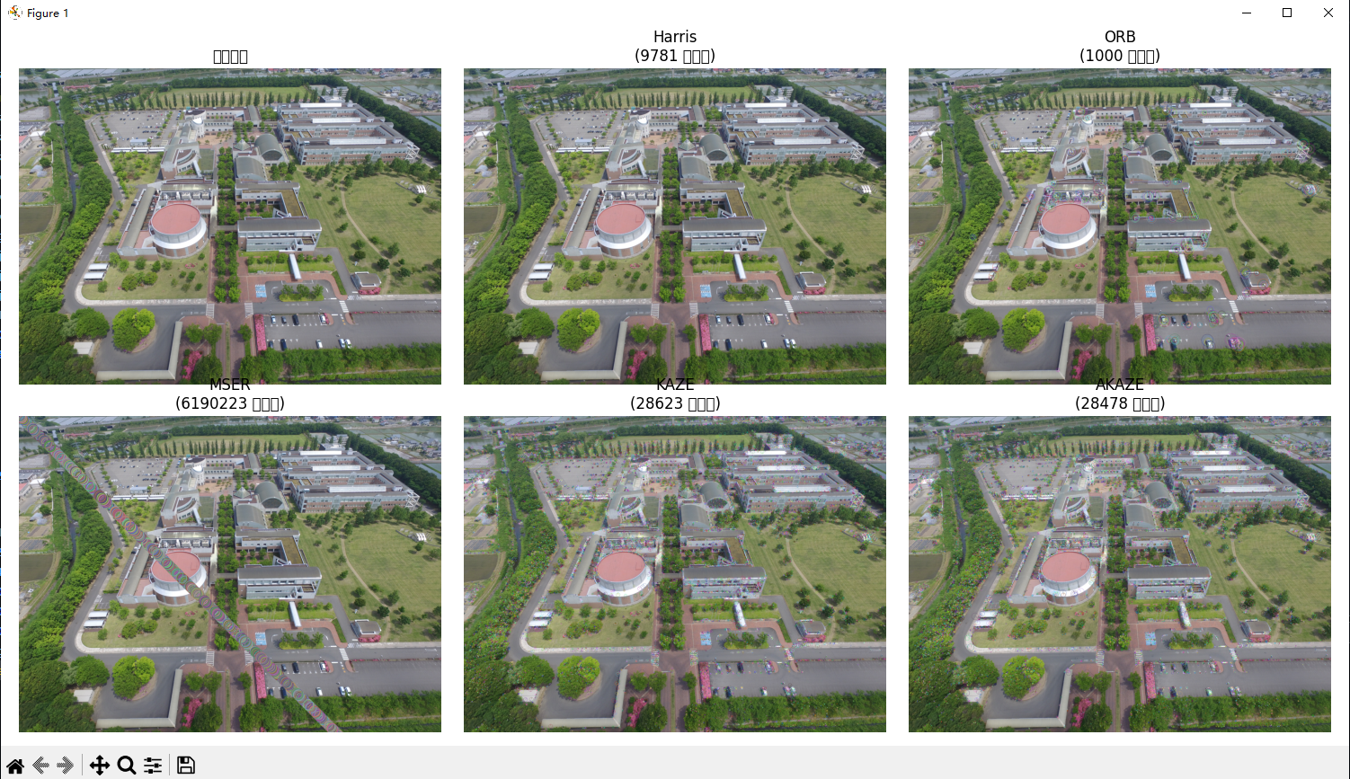

1. Outdoor Scenes

Plain road

Harris detector: 618 features detected

ORB detector: 929 features detected

MSER detector: 138626 features detected

KAZE detector: 323 features detected

AKAZE detector: 185 features detected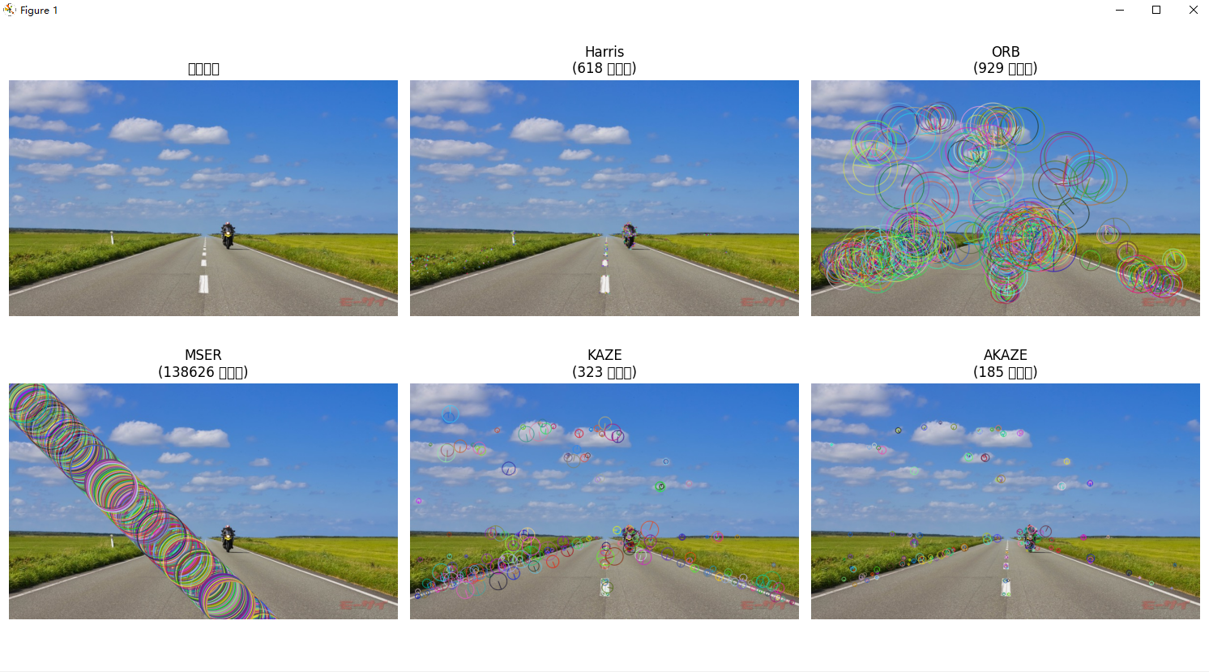

Normal road

Harris detector: 8382 features detected

ORB detector: 1000 features detected

MSER detector: 228151 features detected

KAZE detector: 965 features detected

AKAZE detector: 676 features detected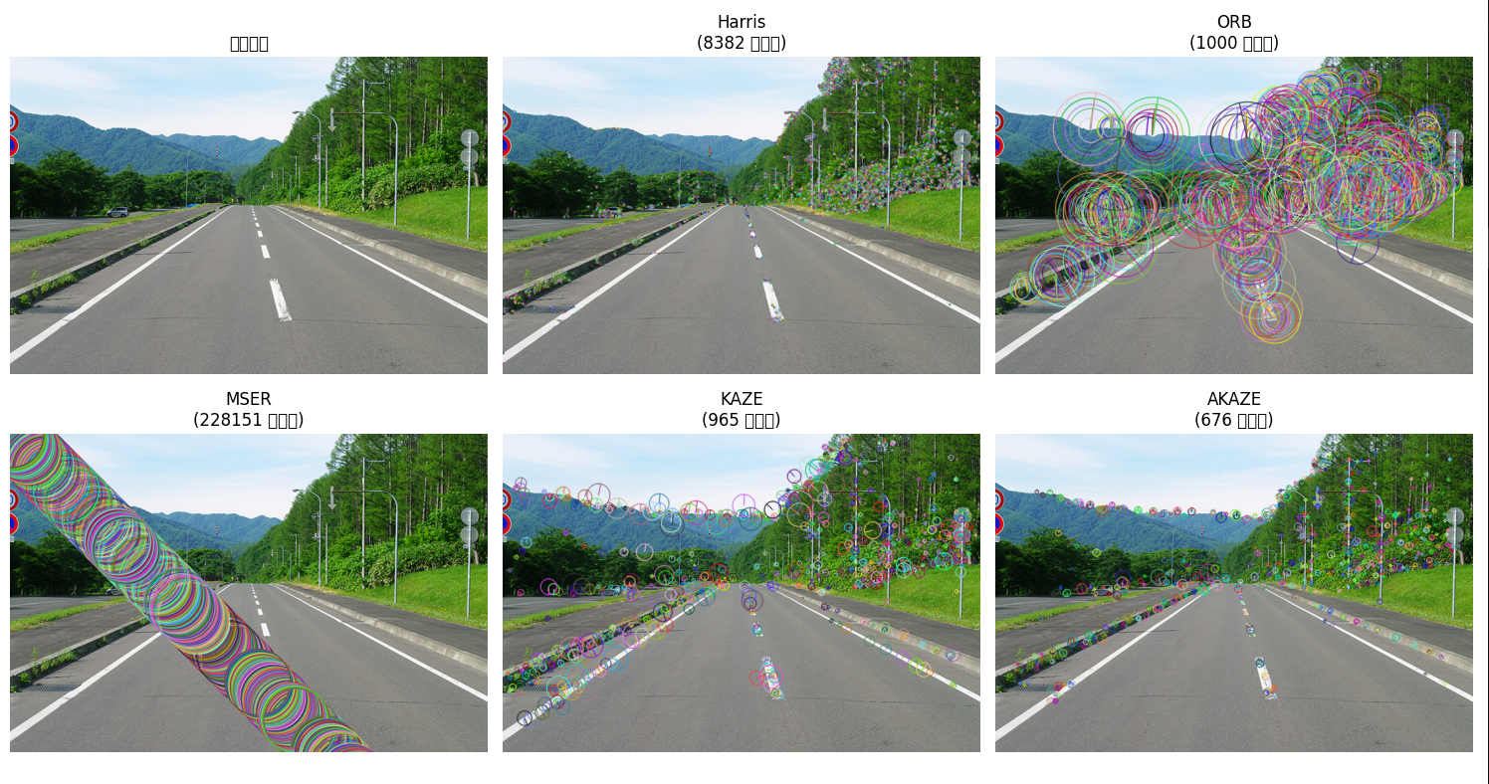

Forestry road

Harris detector: 46977 features detected

ORB detector: 1000 features detected

MSER detector: 919555 features detected

KAZE detector: 4910 features detected

AKAZE detector: 4486 features detected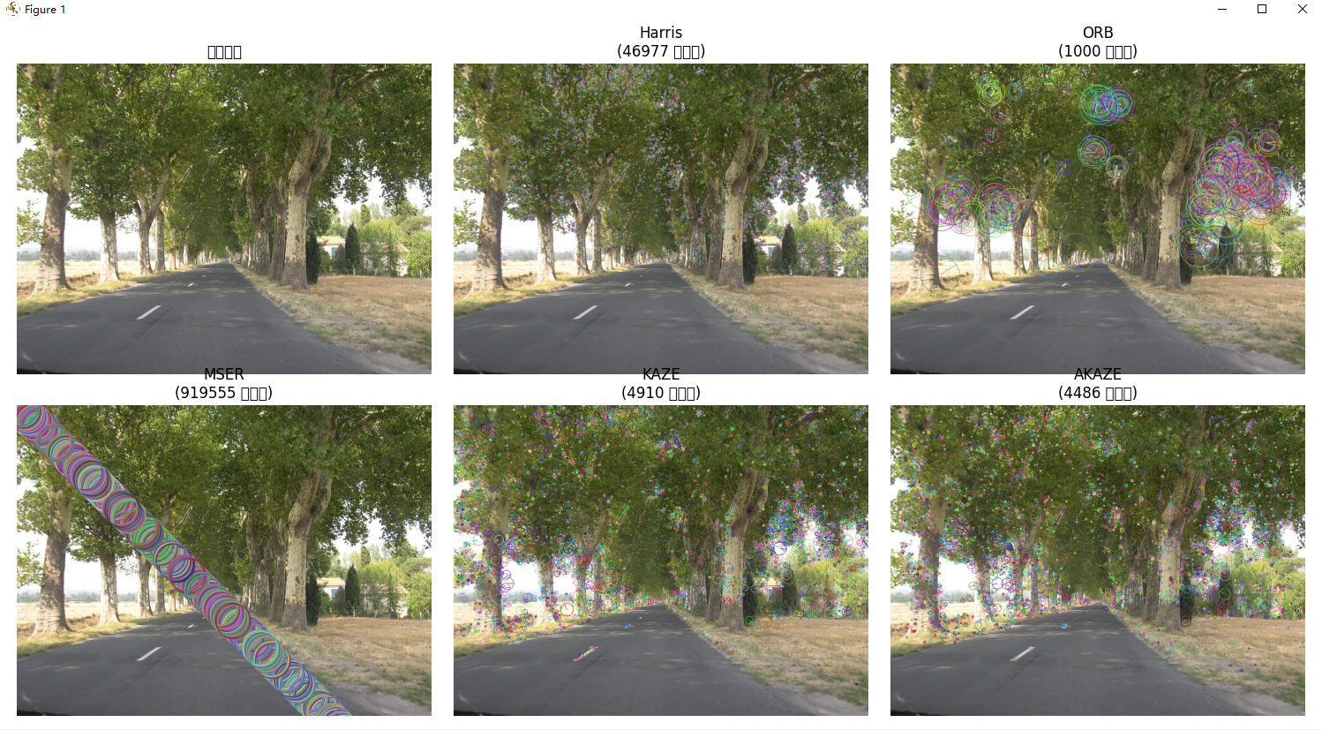

1. Specific Content

Manga characters

Harris detector: 3402 features detected

ORB detector: 1000 features detected

MSER detector: 1745182 features detected

KAZE detector: 3630 features detected

AKAZE detector: 3236 features detected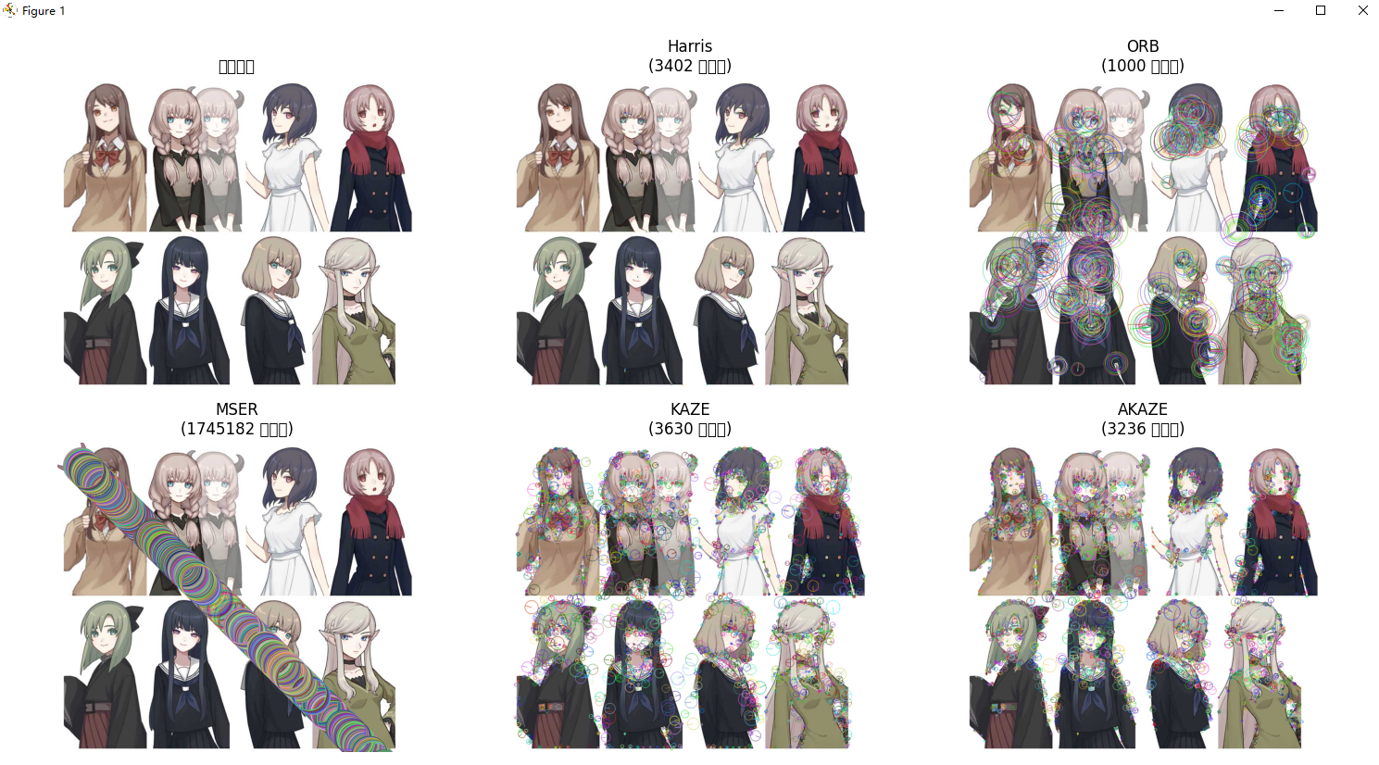

People/portraits

Harris detector: 2624 features detected

ORB detector: 1000 features detected

MSER detector: 1533807 features detected

KAZE detector: 2383 features detected

AKAZE detector: 1702 features detected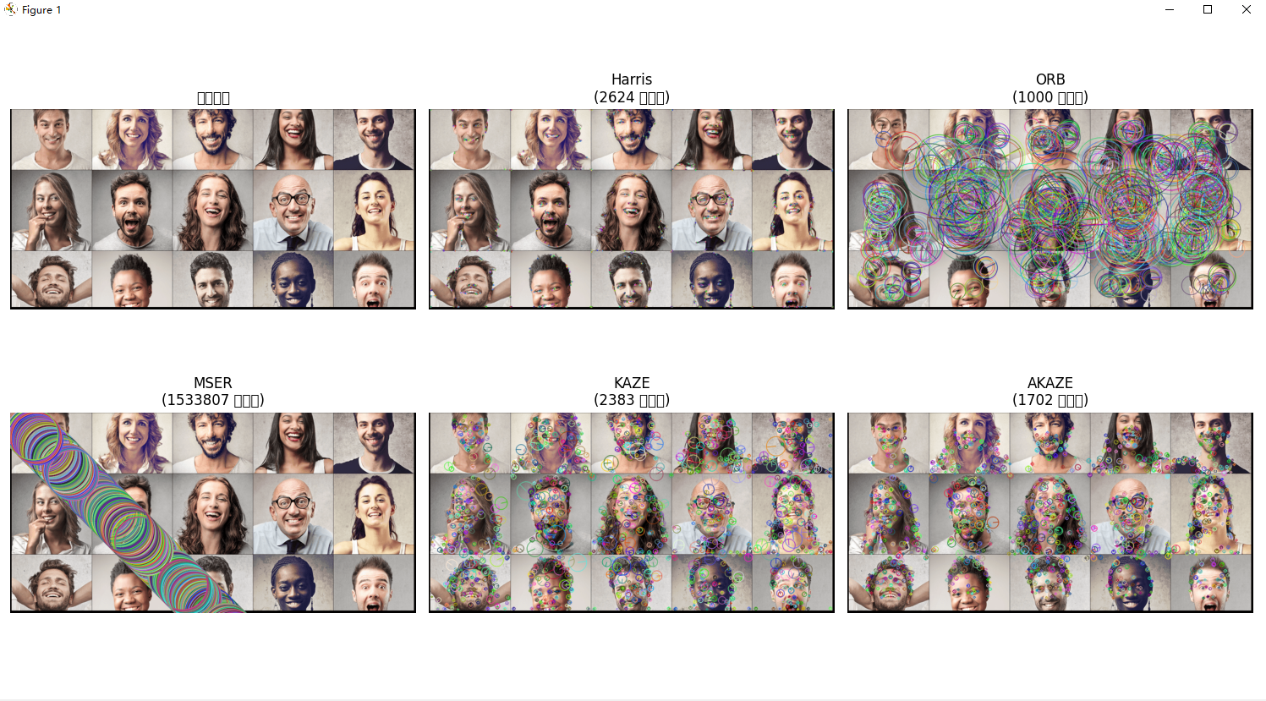

Comparative Analysis

